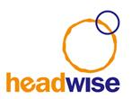
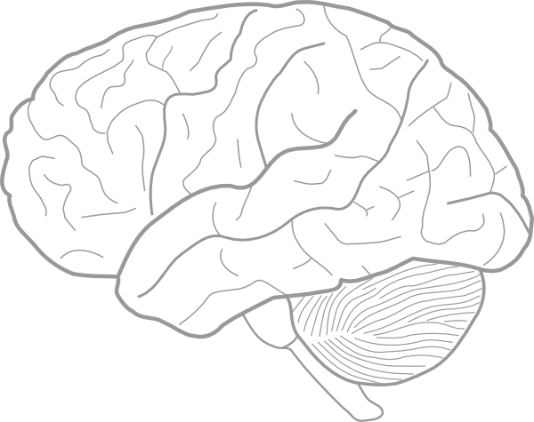

Headwise 2nd Annual Conference
MANCHESTER – THURSDAY 13 JULY 17
9.30am – 1.00pm – free event
Venue: Novotel Manchester Centre, 21 Dickinson Street, Manchester, M1 4LX
We are delighted to announce the second Headwise conference to be held on 13 July 2017 in Manchester. This event is open to case managers, solicitors and any discipline who work with brain injury or neurological disorders.

The conference will focus on:

- Care giver burden
- Cognitive Communication Disorder
- Homelessness and brain injury
- Occupational therapy – case study illustrating an MDT approach.
- PTSD and mild brain injury

Speakers to include:

Dr Andrew Worthington, Director, Consultant in Neuropsychology & Rehabilitation;
Dr Alan Gray, Clinical Psychologist;
Naomi Saul, Speech and Language Therapist
Alexa Hazell, Neuro-Occupational Therapist
** More speakers to be confirmed nearer the time **

If anyone would like to register a place please contact Della Brophy who is coordinating this event: Email: dbrophy@headwise.org.uk or telephone: 0121 222 5342.
